**Topic 5: Real Estate**

Real Estate Investments



* Commercial real estate
* Commercial mortgage-backed securities
* Farmland
* Real estate investment trusts (REITs)
* Residential real estate
* Timberland

1. **Describe the following characteristics of real estate as an asset class:**

* Heterogeneity

Real estate is a highly heterogeneous (different from each other) asset. Varying lease structures can lead to large difference in income streams. This high level of heterogeneity is a major contributor to the lack of correlation between numbers of real estate investments.

* Indivisibility

Investors are faced with the problem of ‘all or nothing’ with some of their investments.

* Liquidity

Real estate is highly illiquid, especially when compared to stocks and bonds.

**2. Explain how the behavior of private and public real estate investments reflects a mix of equity and debt behaviors.**

* Tenants who pay rent is cash flow like debt
* MBS has cash flows like equity

**3. Describe the main characteristics of private and public commercial real estate equity and debt investments.**

Commercial Real Estate can be divided into four classes using two criteria: 1) whether private or public 2) whether they are debt or equity

Private Commercial real estate EQUITY

Investors have the ability to choose specific properties; they have direct control of their investments; and, finally, they enjoy the potential for tax-timing benefits. Farmland, Timberland, Residential and Commercial Real Estate.

Private Commercial real estate DEBT

Private commercial real estate debt can be held as directly issued whole loans, commingled vehicles or commercial mortgages held in funds.

Public Commercial real estate EQUITY (REITS: equity, mortgage, hybrid, TRUSTS)

REITs are a form of public real estate. (Publicly traded on the exchange). Advantages include liquidity, grater investor access, relatively low transaction costs, the potential for better corporate governance structures, and the transparency brought by pricing in public capital markets.

Public Commercial real estate DEBT (CMBS)

Public commercial real estate debut is primarily comprised of commercial mortgage-backed securities (CMBSs). A CMBS consists of many single mortgage loans that are pooled or grouped together and transferred to a trust. The trust then issues bonds, or tranches, that may vary in yield, duration and payment priority.

Real Estate Indices

* Appraisal-based index
* Data smoothing
* Hedonic-price method
* Repeated-sales pricing
* Sample selection bias

**1. Describe the main characteristics of private and public real estate equity and debt indices.**

Private

* NCREIF Property Index (appraisal valuation)
* NCREIF Farmland Index (appraisal valuation)
* NCREIF Timberland Index (appraisal valuation)
* S&P/Case Schiller Home Price Indices (repeated sales)
* MIT Transactions Based Index (transaction, hedonic, published quarterly)

Public

* The FTSE NAREIT (National Assoc. of Real Estate Investment Trusts) (transaction)
* Dow Jones REIT Index (transaction)

Private and Public Debt

* Gilinerto-Levy Commercial Mortgage Performance Index
* Lehman Brothers CMBS Index

**2. Explain the effects that on real estate indices may have the presence of the following potential biases: Real Estate Index Biases.**

* Sample selection Bias: the properties that are transacted during a particular period and used to calculate these indices may not be representative of the entire universe of properties.
* Illiquidity induced Bias: it is argued that total returns generated from real estate investments should reflect a liquidity premium
* Data smoothing Bias: is a phenomenon that not only causes compressed volatility in valuation based real estate indices when compared to the underlay property market prices, buy also generate a lag effect when value changes are recognized by indices on a deleted basis.

**3. Explain the appraisal and transactions-based methods used for constructing real estate indices.**

* Appraisal

These indices use appraisal values instead of real prices. The major problem is that you have a lag which causes Smoothing.

* Transactions-based

Based on actual transaction prices. Hedonic and Repeated Sales. Hedonic is statistical and based on factors. Repeated Sales uses sales pairs (recent – last).

Real Estate Equity Valuation

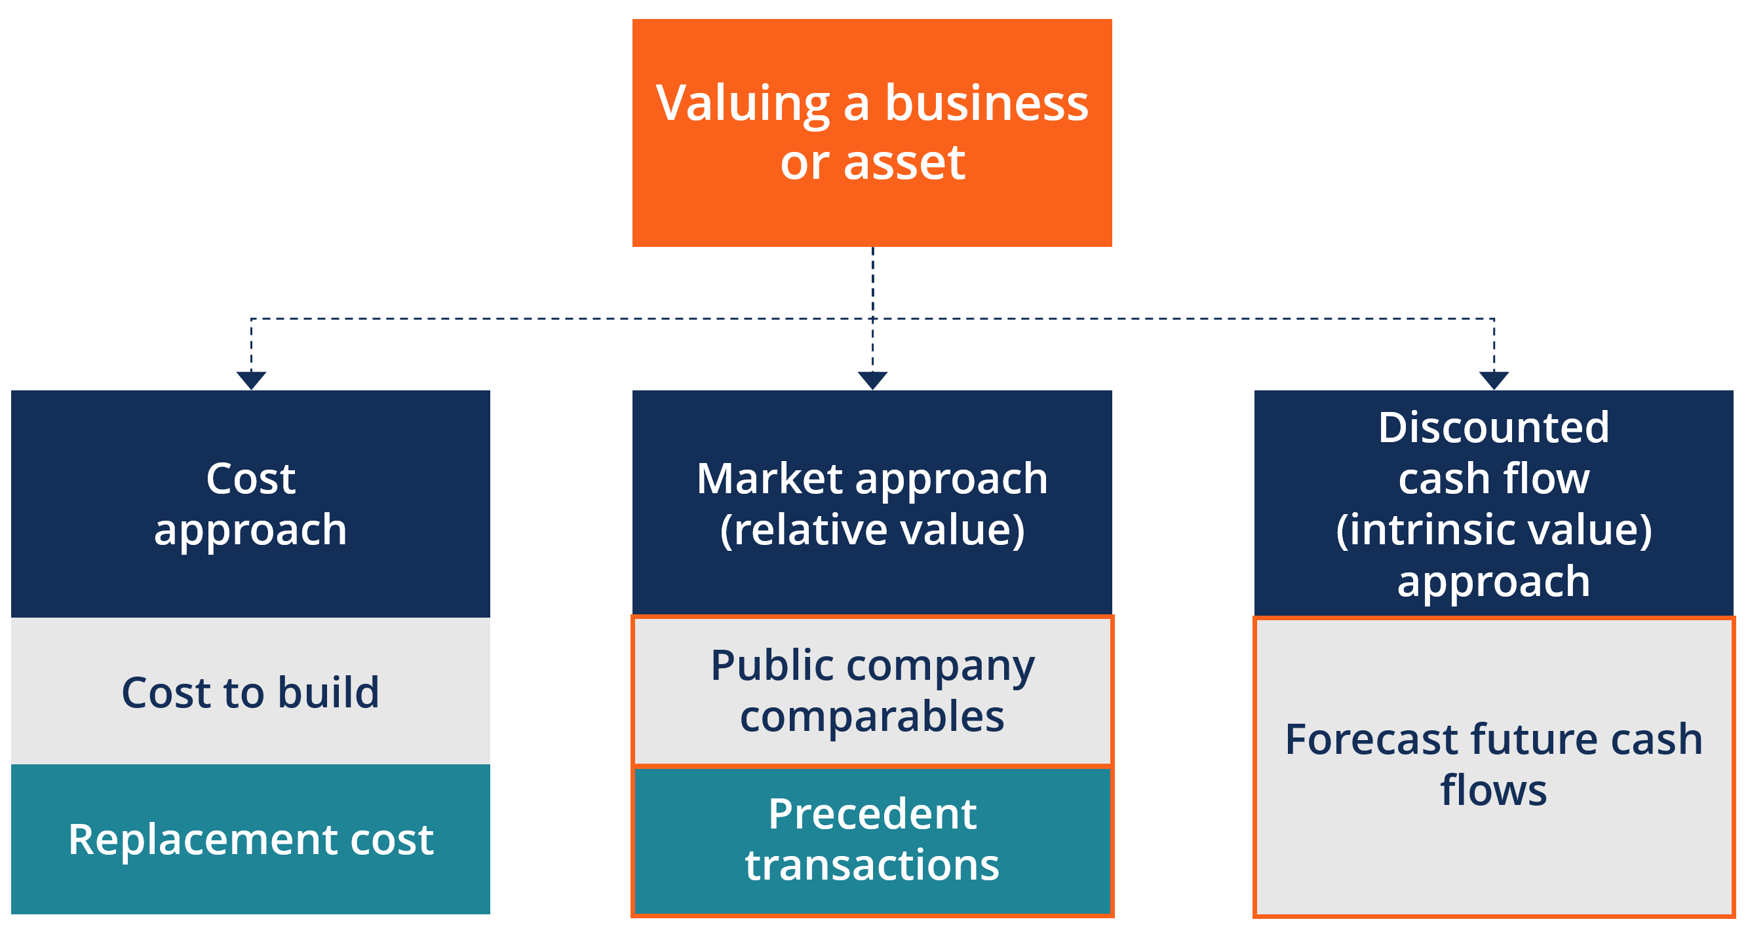

* Adjusted funds from operations (AFFO)
* Depreciation
* Effective gross income
* Funds from operations (FFO)
* Net sale proceeds
* Potential gross income
* Vacancy loss rate

**1. Calculate the value of private commercial real estate equity using the income approach.**

*** See Calculator Document

**2. Explain the logic for valuing private commercial real estate equity using the comparable sales (when no income) prices method and the profit approach.**

Private commercial real estate with no cash flows to measure:

1. Comparable Sales: For non-income producing properties, such as an owner-occupied single family residence, a DCF approach is not viable.
2. Profit Approach: The profit approach is typically used for properties with a value driven by the actual business use of the premises. This is effectively a valuation of the business rather than a valuation of the property itself. The valuation approach is related to the comparable sale prices method but focuses on value from the business use.

**3. Explain how to use the net asset value (NAV) assessments methods to determine whether a real estate investment trust (REIT) is under or overvalued.**

* Buying REITs that trade at a discount to NAV and short selling REITs that trade at a premium to NAV has proven to be a profitable strategy, yielding a monthly alpha of .9% to1.8%

**4. Calculate the value of a REIT using the Discounted Cash Flow (DCF) valuation.**

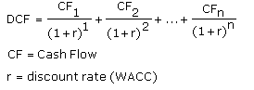

**5. Calculate the value of a REIT using the dividend discount method (DDM).**



CONSTANT GORDON GROWTH MODEL g = rr x ROE or = b x ROE

**6. Discuss whether REITs’ prices are affected by the behavior of the aggregate STOCK MARKET.**

* PUBLIC > PRIVATE (for stock market)
* Reasons include differences income, index methodology, valuation methodology, liquidity, and investors.

Real Estate Investment Risks and Due Diligence



* Business risk
* Financial risk
* Inflation risk
* Legal risk
* Liquidity risk
* Management risk

**1. Analyze the effects of specific RISKS in REAL ESTATE investments.**

* Business risk

Supply and demand

* Financial risk

Risk involved when using debt

* Liquidity risk

Liquidity always a problem with real estate

* Inflation risk

Inflation can be a problem.

* Management risk
* Legal risks

NOTE: An office building is INFLATION and FINANCIAL

**2. Describe the main elements of due diligence in real estate investments.**

Hint: Think about buying an apartment. Lease / Inspection / Location (environment)

* Financial due diligence
* Document verification
* Property inspection
* Environmental assessment

**3. Describe the basics of the use of real estate DERIVATIVES in risk management.**

* Futures and options
* CDS
* REIT Mutual Funds. Note: REITs are considered a derivative
* REIT ETFs.

They all should improve risk management, liquidity management, and transparency for investors.

Residential and Commercial Mortgages

* Balloon payments
* Capped interest rates
* Covenants
* Cross-collateral provision
* Debt Service Coverage Ratio (DSCR)
* Effective cost of a mortgage
* Fixed Charges Ratio
* Fixed-rate, constant payment, fully
* amortized loans
* Foreclosure
* Graduated payment loans
* Index rate
* Interest Coverage Ratio
* Interest-only mortgages
* Margin rate
* Lien Theory: under the lien theory – the lender, or mortgagee, has the right to force a foreclosure if default occurs.
* Loan-to-value
* Option adjustable mortgage loans
* (option ARMs)
* Prepayments
* Title Theory: the title, and therefore ownership of the property, is actually transferred to the lender.
* Variable or adjustable rate mortgages
* (ARM)

1. **Describe the main characteristics of fixed-rate, constant payment, fully amortized mortgages and calculate monthly mortgage, interest and principal payments, and outstanding balances on such loans.**

**See Calculator Page**

**2. Describe the main characteristics of variable or adjustable rate mortgages (ARMs) and calculate monthly mortgage, interest and principal payments, and outstanding balances on such loans.**

**See Calculator Page**

**3. Describe graduated payment loans and option adjustable rate mortgage loans**

**(option ARMs) and calculate the monthly payment of a mortgage possessing a balloon payment.**

**See Calculator Page**

**4. Describe the main characteristics of commercial mortgages.**

* Borrowers
* Income generation
* Balloon payment
* Usage
* Covenants
* Cross-collateral provisions

**5. Explain how to use the four most widely employed financial ratios for commercial mortgages and default risk.**

1. Loan-to-Value

The loan-to-value (LTV) ratio expresses the amount of a first mortgage lien as a percentage of the total appraised value of real property.

For instance, if a borrower wants $130,000 to purchase a house worth $150,000, the LTV ratio is $130,000/$150,000 or 87%.(LTV)

1. Interest Coverage Ratio



1. Debt Service Coverage Ratio (DSCR)

DSCR =

(Annual Net Income + Amortization/Depreciation + other non-cash and discretionary items (such as non-contractual management bonuses))

/ (Principal Repayment + Interest payments + Lease payments)

1. Fixed Charges Ratio



Mortgage-Backed Securities (MBS)



* Accrual tranches (Z-bonds) Collateralized Mortgage Obligations
* (CMO)
* Commercial mortgage-backed
* securities (CMBS)
* Conditional Prepayment Rate (CPR)
* Conduit
* Conduit’s average margin (excess
* interest)
* Contraction risk
* Extension risk
* Floating-rate tranches
* Interest-only (IO) collateralized
* mortgage obligations
* Mezzanine loans
* Mortgage-backed securities (MBS)
* Pass-through mortgage backed
* securities
* Planned Amortization Class (PAC)
* tranches
* Principal-only (PO) collateralized
* mortgage obligations
* Public Securities Association (PSA)
* Refinancing burnout
* Residential mortgage-backed securities (RMBS)
* Sequential-pay collateralized
* mortgage obligation
* Single monthly mortality rate
* Sub-prime mortgages
* Z-bonds (accrual tranches)

**1. Describe the main characteristics of the residential mortgage backed securities (RMBS) market.**

Dominated by the following three main mortgage agencies:

1. The Government National Mortgage Association (Ginnie Mae),
2. Federal National Mortgage Association (Fannie Mae), and
3. Federal Home Loan Mortgage Corporation (Freddie Mac).

**2. Calculate single mortality rates (SMM) and conditional prepayment rates (CPR) and know how to predict prepayments based on the Public Securities Association**

**(PSA) prepayment benchmark.**

* CPR = 1 - (1 - SMM)12

**3. Explain and calculate how cash flows are allocated in a two-sequential pay tranche Collateralized Mortgage Obligation (CMO).**

* Sequential-pay collateralized mortgage obligation is the simplest form of CMO. In a sequential-pay CMO each tranche receives a pre-specified share of the interest payments based on the tranche coupon and potentially receives principal based on seniority.
* The “first-pay” tranche (tranche “A”) will receive all principal prepayments until the tranches face value has been repaid.
* Extension risk and contraction risk

**4. Explain the basics of the following CMO types:**

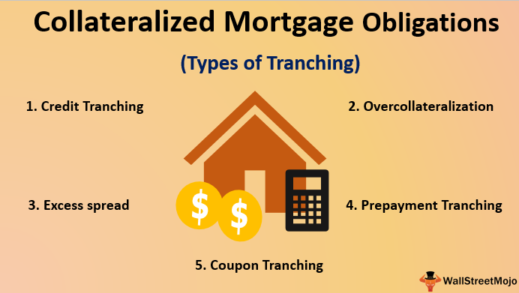

Accrual tranches or Z-bonds

Receive no interest payments, effectively acting as a Zero-coupon bond. The interest payments scheduled for the accrual bond are instead redirected towards other tranches that are receiving principal payments to provide further principal reduction in those tranches.

Principal-only and interest-only

PO and IO. Are created by dividing the total cash flows from the mortgage collateral into the portion that is interest and the portion that is principal repayment.

Prepayment risk tends to be severe for POs and AIOs, with one profiting when the other suffers.

IO on a fixed rate mortgage will increase in value when interest rates increase, because the speed of prepayments decreases and therefore the owner of the IO will receive interest payments for a longer period of time.

Planned Amortization Class (PAC) tranches

PAC tranches receive principal payments in a more complex manner than sequential pay CMOs. PAC CMOs have a main tranche and a support or companion trances.

Floating-rate tranches

Earn interest rates that are linked to an interest-rate index, such as the LIBOR. Floating rate tranches can have rates that move even more than the underlying index and even in the opposite direction (inverse floaters).

**5. Explain the main characteristics and the different structures under which a**

**Commercial Mortgage Backed Security (CMBS) can be structured.**

* Mortgage-backed securities secured by commercial property loans.

**6. Calculate a CONDUIT’S average margin or excess interest**

* Conduits buy commercial real estate loans from issuers such as commercial banks, S&Ls, mortgage bankers and insurance companies. They repackage the loans and then sell CMBSs backed by the underlying loans.
* Assume 150,000,000 Pool of 7% loans. Conduit divides the loan pool into 4 tranches.

= (Weight x %) + (Weight x %) + (Weight x %)

Average margin (or excess interest) = 7% - 5.86%

**7. Identify the risk factors affecting Residential Mortgage Backed Securities (RMBS) and compare them to the risk factors affecting Commercial Mortgage Backed Securities (CMBS).**

* RMBS vs. CMBS
* Residential is usually more insured than Commercial
* Less risk of default for Residential
* Commercial are more complex
* Underlying loans for Commercial are more heterogeneous

CMBS default factors:

* Type of commercial property
* Location of the property
* Quality of the tenants
* Lease Terms
* Quality of Property Managers
* Year the Loan was originated
* Loan to Value (LTV)

**8. Explain the main determinants of the US real estate and mortgage crisis of 2007-2008.**

* Sharp decline in home prices
* Mortgages were being issued too easily. SUBPRIME
* Reduced lending standards
* Increase in new lenders
* Loan securitization
* Growth in non-GSE MBS
* Non-traditional mortgages

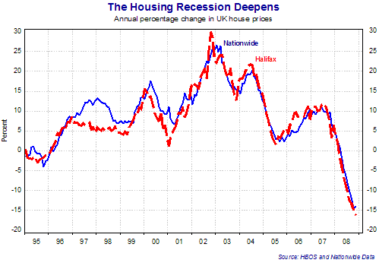

Real Estate and Asset Allocation



* Geographical diversification

**1. Explain the relation between real estate prices and selected MACROeconomic variables.**

* The yield curve
* Real interest rates
* Unanticipated inflation
* Growth in Consumption
* Local GNP and globally aggregated GNP

**2. Describe the role of real estate in an investor’s portfolio.**

* Allocations of 5-10% of the total portfolio are typical for Real Estate
* Risk and Return characteristics are somewhere between stocks and bonds

Issues which constrain real estate investing

* Large capital requirements
* Illiquidity
* Long-term horizon

**3. Explain the main problems in relation to diversification that a real estate manager faces.**

* Heterogeneous – hard to allocate in a portfolio
* Indivisible – hard to allocate in a portfolio

**4. Describe the diversification benefits of REITs investing.**

* Low correlation with assets. Returns were strong from 1991 to 2007

**5. Describe the performance of real estate by sectors and the potential for geographical real estate diversification.**

* Real estate returns are highly correlated across geographic regions in the United States. This implies minimal benefits to geographical diversification.

Alternative Real Estate Investment Vehicles



* Closed-end real estate mutual funds
* Commingled real estate funds
* (CREFs)
* Exchange-traded funds based on real
* estate indices
* Gearing
* Joint-venture
* Limited partnerships
* Managed funds
* Open-end real estate mutual funds
* Private equity real estate funds
* Property unit trusts
* Syndications

**1. Explain the main characteristics, advantages and disadvantages of investing in the following alternative private real estate investment vehicles:**

* Open-end real estate funds

Sells shares to stockholders to raise capital

* Private equity real estate funds

Pooled capital in private real estate

* Commingled real estate funds (CREFS)

Pooled capital that is invested in real estate

* Limited Partnerships.

Combines benefits of partnerships, gearing, limited liability

**2. Explain the main characteristics of the following alternative private real estate**

**investment vehicles: syndications and joint ventures.**

* Syndications:

Syndications are formed by a group of investors who retain a real estate expert with the intention of undertaking a real estate project. Usually developers who require extra equity capital to commence a project raise money through syndication. Legally, real estate syndication may operate as REITS, as a corporation, or as a limited or general partnership.

* Joint Ventures:

Joint Venture consists of the combination of two or more parties, typically represented by a small number of individual or institutional investors, embarking on a business enterprise such as the development of real estate properties.

**3. Explain the main characteristics of the following alternative public real estate investment vehicles:**

* options and futures on real estate indices

CME Group began listing housing futures and options in May 2006. These contacts are based on the S&P/Case Shiller Housing Index of 10 US cities. It is expected that derivatives products will help increase the transparency and liquidity in the real estate market in the coming years.

* exchange traded funds (ETFs) based on real estate indices

ETFs are a stable investment vehicle that tracks a particular index by holding its constituent assets.

* closed-end real estate funds.

A closed end fund is an exchange traded mutual fund that has a fixed number of shares outstanding. Closed-end funds issue a fixed number of shares to the general public in an IPO and in contrast to the case of open end mutual fund, shares in closed end funds cannot be obtained from or redeemed by the investment company.

**4. Describe the main issues of cross-border investments in real estate.**

* Lack of knowledge of other country
* Small scale markets
* Lack of access
* Cultural differences
* Foreign exchange risk
* Political risk

**5. Describe the most salient elements of the performance of selected alternative real estate investment vehicles.**

* 2001 to 2007 selected real estate portfolios outperformed both stocks and bonds. They also had higher Sharpe ratios

Real Estate Development

 Note: “Spire development”

* Discounted cash flow (DCF)
* approach
* Forward sales
* Full forward funding
* Industrial sector
* Office sector
* Residential developments
* Residual method
* Retail developments

**1. Discuss the stages of the development process and the associated risks and expected returns. ESSAY**

1. Acquiring
2. Forecasting
3. Designing
4. Securing approval
5. Raising capital
6. Building
7. Leasing
8. Selling

**2. Compare and contrast the key factors of a feasibility study for residential, retail, office and industrial developments.**

Residential

* Housing trends
* Demographic trends
* Political boundaries
* Mortgage financing issues
* Schools and Commuting trends

Retail

* Location

Office and Industrial

* Research
* Warehouse
* Potential target tenants

**3. Discuss key factors and inputs required to appraise a development project.**

* DCF is obviously the most common
* Local market conditions
* Demand for the space
* Investment market conditions
* Overall supply consideration
* Quality of the building
* Time expected to complete the project

**4. Use the discounted cash flow approach (DCF) to calculate the net present value of a proposed development project.**

****See calculator page

**5. Compare and contrast the methodologies, benefits and limitations of the DCF approach, the IRR approach, and the residual value approach to appraisals.**

**Pg. 297**

* DCF approach – this is the most accepted approach to real estate valuations
* IRR approach – IRR can also encounter difficulties in a development context when a developer is using this criterion in deciding between mutually exclusive projects.
* Residual Value approach – Gross development - Total Development Expenditures.

**6. Use appropriate decision criteria to choose between two potential mutually exclusive development projects.**

* NPV is the criterion of choice

**7. Discuss the factors that LENDERS examine when considering financing a development**

* Financial Strength of Borrower
* The Speculative Nature of the project
* Terms of the loan agreement
* Loan to Value (LTV)

**8. Compare and contrast forward sales and full forward funding.**

* Forward Sales: investor will purchase the development on completion.
* Full Forward Funding: like forward sales with short term financing included

REIT Momentum and the Performance of Real Estate Mutual Funds DerWall



1. **Compare and Contrast the literature on the factors that explain REIT returns**

* Titman and Wargo

REIT returns are not captured by the stock market

* Chen, Hsieh, Vines

Company specific factors are important for describing REIT returns

* Chui, Titman

REIT momentum is not captured by existing models

* Damodaran and Liu

REIT managers add value but do not account for REIT momentum

1. **Describe the five models that are used to measure the performance of REIT portfolios**
2. Single Factor CAPM
3. Single Factor REIT CAPM
4. Fama and French Three Factor Model
5. Carhart Four Factor Model
6. REIT Momentum model

Less factors means more credit for the manager

1. **Discuss the role of REIT momentum in explaining REIT mutual fund performance and performance persistence**

* Different than Carhart model with larger R-squared measures

1. **Discuss the three main practical implications of the study**
2. Factor models are important. Indexing a better way to invest.
3. Abnormal Returns of REIT managers may be smaller than previously suggested
4. Fees for REIT managers may need to be re-evaluated

Assessing and Managing Risk in Institutional Real Estate Investment



* Alpha
* Beta
* Core risks
* Enterprise risk
* Epsilon
* Gamma
* Global investing risks
* Leverage risk
* Manager incentive risk
* Metro Area allocation risk
* NPI swaps
* Obsolescence
* Opportunistic risks
* Property selection
* Property-type allocation risk
* Reinvestment risk
* Value-added risks

**1. Compare and contrast the standard deviation with downside risk in the context of real estate investing.**

* Standard deviation may not be a good measure of private real estate risk because properties are illiquid and rely on appraisal values.
* Investors prefer to use downside risk

**2. Compare and contrast beta risks, alpha risks and gamma risks and their components as described by Kaiser and Clayton.**

* Alpha: the ability to select undervalued properties
* Gamma: the ability to enhance the values of the purchased properties
* Beta risks: Encompasses the risks (and returns) related to broad market trends. 1) Benchmark or Index selection 2) Leverage 3) Obsolescence 4) Capital Market Cycles 5) Demographic trends 6) Real Estate Cycles 7) Manager incentive risks
* Alpha risks: 1) Property Type allocation risks 2) Metro Area Allocation Risk -- location 3) Property Selection 4) Enterprise Risk 5) Reinvestment Risk. More MACRO.
* Gamma isks: Particularly with ground up development or re-development, there are all sorts of risks. Vacancy, construction, strikes, liquidity risk. More specific.
* Epsilon risk: Idiosyncratic risk. Uncertainty in the commercial real estate space.

**3. Compare and contrast the risks of core, value-added, and opportunistic properties.**

* Core: Core is generally considered the lowest risk method for investing in private market real estate. The biggest risk facing core investors, however, is probably the risk of a pervasive valuation shift due to capital market forces.
* Value-added: First of all, there is usually the prospect of higher leverage, perhaps 40-50% loan to value, or more, where the basic volatility is about double that for the NPI Index.
* Opportunistic: identical to value added – just bigger stakes involved.

Real Estate returns were highly correlated across the United States

* Office sector has a higher Sharpe Ratio
* Apartment sector has a higher return

**4. Describe the steps that institutional investors can take to limit risks. Include a discussion of the time horizon used to analyze data, naive versus strategic diversification, and hedging with swaps.**

In Order to Limit Risks:

* Diversification

Naïve diversification (40-50) properties and Strategic diversification (across characteristics)

* Hedging

Swaps using NPI can be used to hedge against downside risk

* Data Analysis Time Horizon

5 year rolling windows

U.S. Timberland post-recession: Is it the same asset?

Note: “Timberland”

* Average per acre value
* Cap and trade
* Carbon credit
* NCREIF Timberland Index of Return
* Paper
* Real price appreciation rate (RPAR)
* Unanticipated inflation
* Wastewood

**1. Compare and contrast the evolution of timberland as an investment class through the following four phases: 1983 to 1995 (Phase 1), 1996 to 2000 (Phase 2), 2001 to 2004 (Phase 3), and 2005 to 2009 (Phase 4).**

* Phase 1
* Phase 2 == 18% return 1996-2000
* Phase 3
* Phase 4
* Investors were buyers in each Phase
* Majority of returns are attributable to income

**2. Discuss the performance of timberland over time, distinguishing between income and capital appreciation.**

* Results of the Timberland asset class have DECLINED over time.

**3. Describe appraisal, periodicity, composition and inventory of the NCREIF**

**Timberland Index (NTI).**

* Appraisal (Lagging)

Due to illiquidity of timberland, NTI properties are valued using appraisals rather than market prices. Lagging occurs.

* Periodicity

NTI is a quarterly index. There is potential price manipulation.

* Composition

NTI is very dynamic. Properties to be valued are always changing.

* Inventory

Timber inventory is variable

**4. Explain the benefits of adding timberland to a diversified portfolio of real estate and traditional financial assets.**

* Timberland offers significant value for institutional investors when added to a portfolio consisting of real estate, stocks, and bonds

**5. Defend the role of timberland investments as an inflation hedge.**

* It is a GOOD inflation hedge

**6. Discuss the following components of timberland value: timber component,**

**underlying land value, and parcelization and development value.**

* Timber components

Housing and paper

* Underlying land value

The value of the land

* Parcellation

Referred to as Highest and Best Use (HBU). Price increases when it is developed with infrastructure.

* Development value

Highest and best use. Price increases when the land is developed.

**7. Discuss how the value of timberland is affected by climate change and carbon credits, biomass, Payment for Ecosystem Services (PES),**

* Climate change

Credits are earned by carbon reduction programs.

* Carbon Credits

Cap and Trade program

* Biomass

Timber = energy

* Payment for Ecosystem Service

Compensation paid to property owners in exchange for providing an ecological benefit

Risks, Returns, and Correlations for Global Private Real Estate Markets



* Jones Lang LaSalle’s Real Estate
* Transparency Index

**1. Compare invested and total stock of real estate in the U.S., Asia, and Europe (in general terms), and explain why the differences are important to consider.**

 America

27% of the total stock

54% of the invested to total stock: Ratio.

 Asia

36% of the global total stock

24=6% of the total invested to total stock

 Europe

33% of the total stock

42% of the invested to total stock

**2. Explain why designing an optimal global real estate portfolio is challenging.**

1. Lack of an efficient market
2. Data Limitations

**3. Explain how and why changes in nominal GDP can be used to generate estimates of country specific real estate risk, return and covariances.**

* Real Estate grows when nominal GDP is growing

**4. Compare and contrast approaches for determining portfolio allocations, given the real estate risk, return and covariance estimates.**

1. Textbook Approach

Constraints on the asset weights. Over allocation into risky assets.

1. Practical Approach

Market weights are used as the benchmark